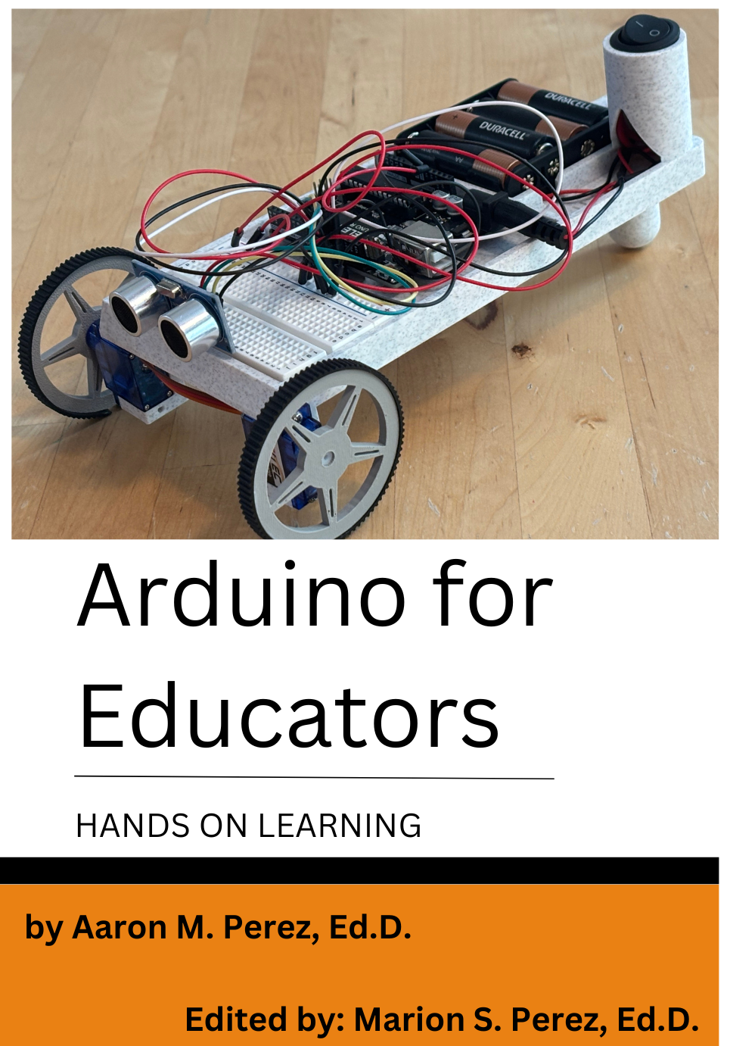

Arduino for Educators
Introduction
Welcome to Arduino for Educators!

This course guide is designed to provide Teachers with the tool to implement a robotics curriculum into their classroom or enhance an existing curriculum. In so doing, students will learn basic scientific and technological understanding of the fundamentals of programming a microcontroller like Elegoo or Arduino. Along the way, students will gain confidence, which will excite learning. Beginning with the end in mind, students will build an autonomous object-avoiding rover.
To learn the skills to complete this task, students will learn to control motors (DC & Servo) and learn how to control their movement with a distance sensor. Students will learn to calculate distance with the sketch (or code) and have the rover avoid objects without manipulating objects in physical space. Students will also learn how to use the same distance sensor to activate a light and sound a buzzer when the rover approaches an object at a predetermined threshold.

The course will begin by offering the student a basic understanding of the capabilities of the Arduino, as well as background information necessary to complete the object-avoiding autonomous rover – Rover X. Through discussion and analysis, the course then delves into the understanding of how this system interacts with objects and the capabilities of the microcontroller.
“Cross-Cutting Concepts'' (P. 79) will link the application of Space Science to Computer Engineering, Math and Physics. A brief introduction to the Mars environment and space exploration will be covered with a focus on rover development for space design and exploration. This portion will cover the type of environment in which the rovers will interact.
A good background in mathematics is recommended but not required as this course involves a great deal of mathematical concepts, math logic, and explanation of computer programming processes. Upon completion of the course, the student should have established a solid foundation in the collaboration of the Arduino microcontroller.
A couple of things before we move on: 1) Please ensure students can access all the course curriculum and that the Arduino IDE is downloaded on the student computer, and 2) It is important for students to complete each Unit before moving on to the next.

Arduino For Educators
Accessing the Course Website
To access the syllabus, videos, and assignment sheets, go to drplearning.com. Once you gain access to the course website, you will find all the video course materials for each student. The website resource provides a detailed overview of each lesson and provides a clear and easy format for teachers to follow. The website includes the following: PowerPoint video presentations with clear explanations, examples and paid resources to either hand out or post online.

Course Overview
The intended audience of this curriculum is middle school or high school (lessons can be adapted for rigor and relevance). Elementary school teachers in grades 4 & 5 can also apply lessons 0 - 4 into their STEM curriculum.
In general, I use this curriculum with a team of two students. At the end of one Unit, you may choose to move right on to the next unit. For example, you may finish Unit 0 in a day-and-a-half or less, plan and move on to the next unit as you see fit.
- 1st nine weeks - Units 1 - 5
- 2nd nine weeks - Units 6 -7
Upon completion of the course, the student should have established a solid foundation in the use of the Arduino microcontroller and understand the importance of technical sketching for developing and building logical structures.
Assignments
- I encourage you to set up a clear method for submitting assignments electronically with students.
- While due dates are important, it is more important that students learn to master the skills within this curriculum. Tus, the 1st nine weeks for units 1-5, and the 2nd nine weeks for units 6-7.
- It is the choice of the Educator to allow student submissions in the form of a Picture file, a Word Document, a PDF, a PowerPoint, or a Video.
- Assignments may consist of the following: Examples of Project Reflections, Technical Sketches, Arduino Sketches, and Video Submissions are provided in next section.
- Project Reflections: At the end of next week or unit, the instructor will (or may) review the previous week’s work with the student. Based on the instructor’s feedback, the student will write a short reflection. This reflection will help the student with future tasks and the final projects. I recommend teachers allow students to document what they enjoy and do not enjoy about the program and allow the student to be honest. This is a great coaching opportunity!
- Technical Sketches will be submitted in the Final Project Portfolio (see below) throughout the Semester in a hand-drawn format.
- Arduino Sketches will be submitted in the Final Project Portfolio (see below) throughout the Semester in a printed format.
- Video submissions are to demonstrate how the students understand the Arduino code (sketch). Students must describe how the code works. Short videos (10-15 seconds) ensure that the students provide succinct answers and adequate preparation for this assignment.
Final Project
- The Final Project Portfolio may either be submitted in a hard copy or digital format.
  - There are several components to the Portfolio that may be organized into the following sections:
    - Hand-drawn Technical Sketches by Unit
    - Printed Arduino Sketches by Unit
    - Hand-written or printed Reflection Feedback from Teacher.
- For this Video submission, students may upload the video to YouTube or another video platform and include the video in the Final Project Presentation.
  - The project reflections will help with this.
- The Final Project Presentation must be submitted in PowerPoint (or similar) format, and students will present their project to the classroom.
- EXAMPLE of Presentation (Found online)
- This PowerPoint is a Portfolio that details the project from beginning to end.
  - It must answer the following questions.
    - What did the student(s) do to complete the project?
    - How were those things done?
    - Why were the choices made to complete the tasks in that way?
    - Students must also document the project through pictures and provide details about each layer of the project.
    - The project reflections will help with this.
FOR ALL LESSONS
Day 1: For the first day of every lesson, there will be a PowerPoint lesson and supporting videos and files to ensure that the Teacher and student are successful in teaching and learning how to use the Arduino effectively.

Day 2+: For every day after Day 1, the student will either complete a Technical Sketch, an Arduino Sketch, an Arduino Project, and/or video. The Arduino project is an actual project that utilizes the Arduino to control various sensors. Some sketches and projects will be completed quickly, while others will take more time. My encouragement is to allow students the necessary time to master the skills and encourage your students to trust the process. In other words, students may be at various stages of the project and that is ok. Students may not have been exposed to this type of work and may need extra support from the beginning.

Project Reflections
Project reflections are weekly meetings conducted with students either weekly or bi-weekly to discuss their progress and provide feedback for future lessons. I suggest setting up a meeting with each group (or student) during class and keeping those meeting times consistent with students.

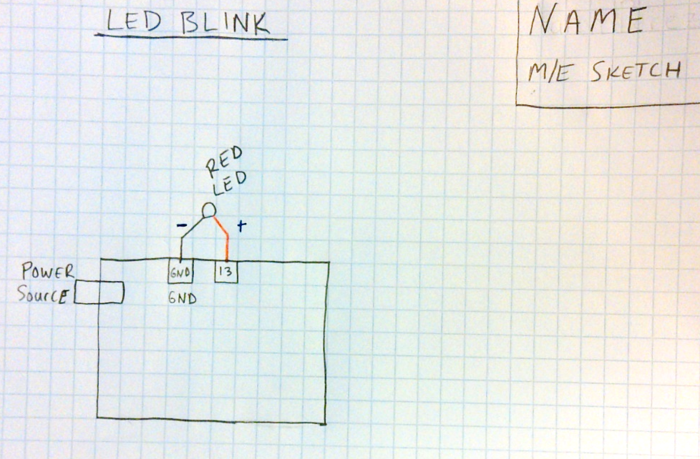
Technical Sketch
In every lesson, students will draw a Technical Sketch for the conceptual understanding of electrical schematics. The sketch will be added to the project portfolio after it is completed. Project Portfolios will be submitted regularly for grading.

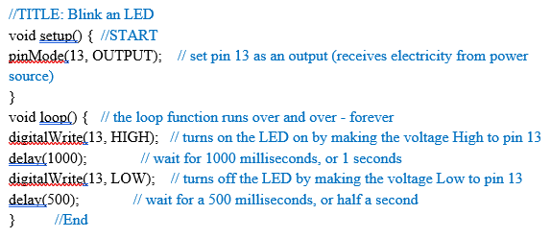Arduino Sketch
Students will write a “description” of what the Arduino sketch (the code) is doing in a logical step-by-step fashion. Here is an example of an Arduino Sketch. There are two portions of a sketch. The first is the code and the second component is the code description. The code is written in black, and the code description is written in blue.
Videos
Students will complete a video for Units 3-7. The video is submitted to demonstrate the functionality of the Arduino project and the student’s understanding of how the code interacts with the real world through the various sensors and “output” sources (i.e., LED’s, motors, buzzers).
Example of a Student Video available online
Assignment Sheet Overview
Each Unit will have a similar Assignment Sheet format (below), and it will generally follow this format. If a section is left out of any Unit and/or lesson, you may assign something in its place.
Lesson Objective: The lesson’s objective or main idea.
Essential Question: The driving question behind the lesson.
Warm-Up Question: The question that will begin the class to start students’ thinking around the unit. This is a quick discussion of 2-3 minutes.
Exit Question: This end-of-class question will either assess student learning during the class and/or begin student’s thinking around the topic for the next class. 2 minutes.
Cross-Cutting Concepts: These are standards for the specific unit that include the Next Gen Standards and Common Core Standards. The Next Gen Standard (Hyperlink) will be provided with adjoining Common Core Standards.
Assignments
Video: 1) The video contained within the lesson may be re-watched or paused. 2) Students will also have video submissions of their projects.
Research: Research that is assigned to enhance student learning. Although I do not grade this overtly, this is one of the more critical pieces that adds to a student’s knowledge base and helps students to develop great presentations. You may choose to grade this as you chose.
Drawing: A technical drawing to organize student thinking around electrical wiring or a design. Drawings may be completed on graph paper or in a 3D modeling computer program, such as Solidworks.
Project: An assignment created by the students to demonstrate their learning. In general, projects are assignments that students complete. Submissions will include pictures, videos, and demonstrations of the completed project which will show its functionality.
Write: Any assignment that may contain writing in it - either in pencil or computer. Examples include, but are not limited to, emails, technical drawings, documents, Arduino Sketches, and PowerPoints.
Overview of Units
The Rover X Project
- Introduction (p. 21): An Introduction to Microcontrollers, Problem Solving & the Mars Environment
- Unit 1 (p. 26): An Intro to Technical Sketching
- Unit 2 (p. 29): An Intro to Breadboarding & Electronics
- Unit 3 (p. 33): Blinking an LED
  - Blink a single LED
  - Blink 2 LEDs (Alternating)
  - Dancing LEDs (3 or more LED’s consecutively)
- Unit 4 (p. 39): Integrating Lesson: The Night Light Challenge
  - Breadboarding through the Night Light Challenge
- Unit 5 (p. 42): Using the Ultrasonic Sensor
  - To Light an LED
  - To Sound a Buzzer
  - To Light an LED & Sound a Buzzer
  - To Control Servo Motors
- Unit 6: Preparing for Rover X
  - The Rover Body Design
  - The LED
  - The Power Switch
- Unit 7: The Rover X Build
  - Final Project: Students will build an autonomous object-avoiding rover.
  - Constructing and coding the Rover.
Materials Needed
Teacher Only: USB Document Camera - V4K (IPEVO Visualizer - for viewing) – Any high-resolution document cameras can be used.
- A computer with internet connection:
- For Arduino IDE download, to access course materials, and research.
- Arduino IDE Download: https://www.arduino.cc/en/main/software
- 1 – 1 inch, 3-ring binder with Seven (7) sections – One for each Unit
- In each Section, students will file each of the following as required by the specific assignment.
- Technical Sketches, Arduino Sketches, Pictures with descriptions, and one Reflection per unit
- For a digital folder system
- Main folder: Arduino Project
- Sub Folders: Unit 1, Unit 2, Unit 3, etc.
  - Each Technical Sketch & Arduino Sketch will be included.
  - One PowerPoint with each picture with a description
  - One Reflection per Unit
- 1 – 70-sheet notebook of Graph Paper
- 1-2 Pencils – preferably mechanical pencils with .7 mm or .9 mm lead
- 1 set - Colored Pencils (8)
--
Project Supplies Needed - Per Team
Prices may vary depending on quantity and location.
Full kits available at drplearning.com ($74.99)
- 1 - Rover X Rover Body - $24.99
- 1 - Dr P Learning Solderless Breadboard - $14.99
- 1 - Arduino Uno R3 or Elegoo Uno R3 (Comes with a cable) – Elegoo R3 provided in kit
- LED’s: (2 Red, 1 Blue, 1 Yellow)
- Resistors (2 of each): 220 Ohm, 10KOhm
- 2 - Photoresistors
- 2 - Continuous Servo Motors with Wheels
- 1 - Ultrasonic Sensor
- 2 - Solderless Breadboards
- 1 - 4 x 1.5v AA Battery Pack
- 4 - AA Batteries
- 2 - Continuous Rotation Micro Servo Motors
- Flexible Jumper wires (Various lengths)
- 1 - Switch
Other Items
- 1 - 12-quart storage container
- Breadboard connectors (Various lengths)
- 1 - Soldering Iron Kit
- 1 - 6pc Mini Screwdriver Kit
- 1 - Anti-Static Work Mat

Introduction
An Introduction to Microcontrollers, Problem Solving & the Mars Environment

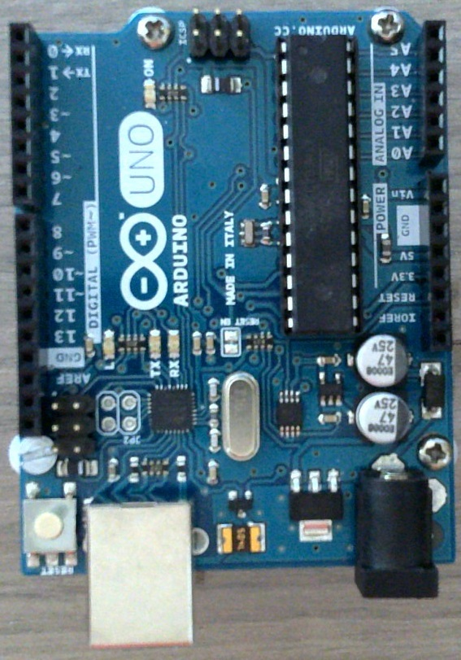

An Introduction to Microcontrollers, Engineering Design & Problem Solving

Lesson Objective
In this unit, students will download the Arduino IDE and connect (interface) the Arduino microcontroller to the correct port on the computer.
Essential Question
What is open source? What is Arduino? How can Arduino be used to solve real-world problems?
Materials: Graph paper, pencil, ruler (or compass)
Cross-Cutting Concepts
Next Gen Standard Addressed
- HS-ETS1-1 Engineering Design (Day 1, 2, 3)
- HS-ETS1-2 Engineering Design (Day 3)
- HS-ETS1-3 Engineering Design (Day 3)

Day 1
Arduino Intro
Warm Up Question: How do robots make life easier?
Exit Question: Why do you think open source is important in the modern world?
Assignments
- Video: Watch the Ted Talk by Massimo Banzi on Arduino Open-Source Imagination.
- Questions after the video
  - How would you define open-source imagination?
  - What problems did you see in the video that Arduino solved?
  - What problems do you see in your life that Arduino could help you solve?
- Article: Please research an article on a project at Google that solves a world problem using computer programming and robots. This article will help you begin to develop ideas for your final project!
  - Discuss during the next class.
- Hand out student kits and verify Components.
- Ensure students can access the course curriculum.
  - Download & Install Arduino IDE

Day 2
Engineering Design & Problem Solving
Lesson Objective
Essential Question
Warm Up Question:
Exit Question:

Unit 1
An Introduction to Technical Sketching
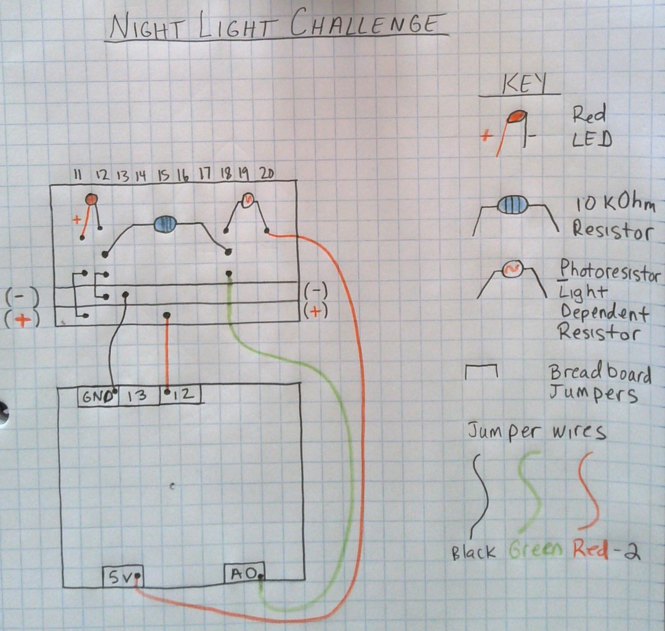

Example of a Technical Sketch - Night Light Challenge

An Introduction to Technical Sketching
Lesson Objectives
1) Students will learn about the basics of technical sketching by creating drawings and labeling them using a key. 2) Students will learn why Technical Sketching is important for Arduino Projects and Engineering Projects.
Essential Question
What is a technical sketch? Why is it important to draw technical sketches before completing an Arduino Project or an Engineering Project?
Materials: Graph paper, pencil, ruler (or compass).
Warm-Up Question: Have you ever drawn a complex graphic and had to use a key to describe different components of the drawing?
Exit Question: After watching the Introduction to Technical Sketching, why is it important to draw Technical Sketches?
Cross-Cutting Concepts
Next Generation Standards Addressed
HS-ETS1-2 Engineering Design

Assignments
Video: Watch the video/PowerPoint on “Introduction to Technical Sketching”
Draw: Replicate the following drawing as a basis for future technical drawings. Please take your time and draw slowly and carefully.
EACH STUDENT must complete the following on GRAPH PAPER and add the physical copy to your Project Portfolio.
Write: Write and email to your instructor and answer the questions using complete sentences:
- What is a technical sketch?
- Why is it important to draw technical sketches before completing an Arduino Project or an Engineering Project?
Unit 2
An Introduction to
Electronics & Breadboarding
This is likely a multi-day project: See additional Warm-up & Exit questions in the Appendix.
Lesson Objective
Students will learn about the basics of electricity and the Breadboarding components used to learn in this project.
Essential Question
How can electricity be controlled to operate or control other objects?

Day 1
Electronics
Warm-Up Question: Think/Pair/Share - Take 60 seconds to discuss with your partner about what you know about how electricity works. Be ready to discuss as a class.
Exit Question: After watching the Introduction to Electronics video, what was something that you did not know before watching the video?
Cross-Cutting Concepts
Next Generation Standards Addressed
HS-ETS1-3 Engineering Design
Warm Up Question:
- What was the article about? What did you learn?
- How was robotics used to solve a real-world problem?
Exit Question: Real World Integration: How does learning to use a multimeter support troubleshooting in more complex electronic projects?
Assignments
- Video: Watch the video Intro to Breadboarding & the Multimeter
- Questions after the video: Select as many or few as you like.
Breadboard Basics
- What are the main sections of a breadboard, and how are the rows and columns internally connected?
- Why are the long side rails on a breadboard typically used for power and ground?
Component Connections
- What are jumper wires, and how are they used on a breadboard?
- How do you properly insert an LED and resistor into a breadboard circuit?
Multimeter Use
- How do you set up a multimeter to measure voltage in a circuit?
- What is the difference between measuring voltage and resistance using a multimeter?
- Why must you remove a resistor from the circuit before measuring its resistance?
Practical Application
- What common mistake do beginners make when measuring voltage on a breadboard circuit?
- Why is it important to understand how the breadboard’s internal layout works before building circuits?
- Subject Line: “Electronics Introduction-Last Name”
- Email Questions to answer:
  - What is electricity?
  - How can electricity be controlled to operate or control other objects?
  - After watching the video, what is something that you did not know before watching the video and seeing PowerPoint.
  - What was something that you learned from researching electricity?

Day 2
Breadboarding
Warm-Up Question: What is the purpose of a Technical Sketch?
Exit Question: How do sketches help us in designing engineering solutions?
Assignments
Video: Review video from Day 1 with students, ensure understanding of key components
Research: You may have students conduct their own research.
Draw: Students will hand draw their first “Technical Sketch” and
- Students will draw an Arduino (with pin assignments), battery source, breadboard, LED, resistor, and wiring.
- Students will use tactical lines (lines that are straight and travel along the grid lines on graph paper).
- Students will complete the Electrical Sketch
  - The teacher will review each sketch individually and provide one-on-one feedback to students.
Write: Students will write a key for their drawing with legible spelling.

Unit 3
Blinking an LED
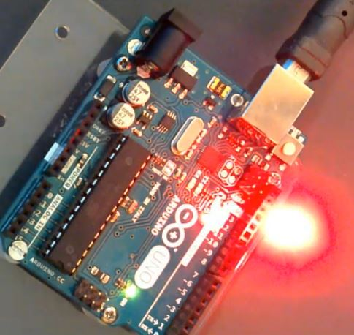

Blinking an LED
This can be a multi-day project: See additional Warm-up & Exit questions in the Appendix.
Lesson Objective
In this lesson, students will begin to learn about and apply computer coding to blink an LED using an Arduino Microcontroller.
Essential Question
After watching this video, what problems do you see in your life that Arduino could help you solve?
Cross-Cutting Concepts
Next Generation Standards Addressed
HS-ETS1-1 Engineering Design
HS-ETS1-2 Engineering Design
HS-ETS1-3 Engineering Design
HS-ETS1-4 Engineering Design
–
Warm-Up Question: What is one application of LEDs in everyday life? What electronics do you have in your home that use LEDs?
Exit Question: How do you slow down and speed up the rate at which the light “blinks”?
Assignments
Day 1
First: Please download and install the Arduino IDE on your computer: https://www.arduino.cc/en/Main/Software (Copy & Paste in your internet browser)
Video: Watch the video titled Arduino Intro & LED Blink
Research: Find an article on a project that solves a world problem using computer programming and robots. This article will help you begin to develop ideas for your final project! Discuss the article at the beginning of the next class with your teacher.
Draw: a Technical Sketch on your graph paper to demonstrate your understanding of how the LED connects to the Arduino. Please turn in the Mechanical Electrical Sketch via email or LMS.
Create: an Arduino Sketch to have an LED Blink “ON” and “OFF” for various amounts of time to have the LED blink on and off. Please take video up to 20 seconds of the lights “blinking” and describe what the code is doing to the electricity and how the light appears to be blinking.
While the code is provided, please type the code out line for line rather than using copy and paste. The final code will not be provided to you - it is important that you understand this process and the commands.
Write: Please write each line of the code (In Black) and label each line of code in your own words (If using Microsoft Word, write the code in Blue).
Save the Arduino Sketch as “Blink - Day 1 - Team Name”
Day 2
Setup
Before the lesson starts, use your document camera to display your Arduino & Breadboard along with the Arduino IDE to work along with students. This is an extension of yesterday’s lesson.
Lesson Objective
Students will build basic circuits and investigate the basic blink program.
Essential Question
What code is needed to make multiple LED’s blink using Arduino?
–
Warm Up Question: What are some of the uses of LEDs in our everyday lives?
Exit Question: Is an LED a light? If not, what is it?
Assignments
Video: Students will research and watch a short video (3-5 minutes) on Light Emitting Diodes and Resistors (You may also assign a video).
- Questions: After the video, ask the students the following questions:
  - What is an LED?
  - What is a Semiconductor?
  - How is an LED a Semiconductor?
- Other Questions:
  - What is a resistor?
  - How do resistors operate in an electrical system?
- Video Discussion
  - After the students answer the questions, the Teacher will briefly discuss the built-in resistor on pin 13 from the video “Arduino Intro & LED Blink”.
  - Model a circuit built on the breadboard with an LED and a resistor plugged into Pin 12. Discuss as a class that would need to be changed to make two LED’s blink alternating.
  - Next, ask, what do you think we could change to make the light blink faster or slower?
Research: See above
Draw: Students will draw an Electrical Sketch blinking 3 LEDs, one on pin 13, one on pin 12, and one on pin 11 - Remind students of the built-in resistor on pin 13.
Create: Challenge: Create a circuit and modify the program to make 3 lights blink.
- Although the Arduino Sketch/Code is provided, I encourage you to type the code for yourself.
- Save the file as
  - 2LEDs-Day 2-Team Name
  - 3LEDs-Day2-Team Name
Write: Have students modify their own code and check for accuracy.
UNIT 4
Breadboarding Through
The Night Light Challenge
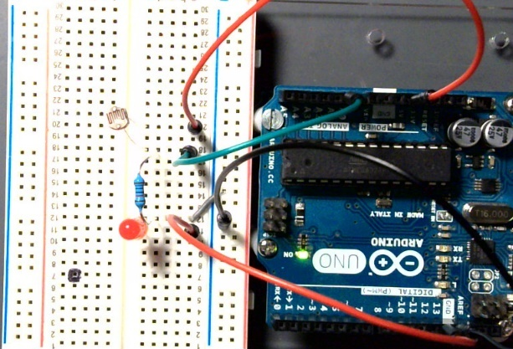Uncovered Sensor – LED Off
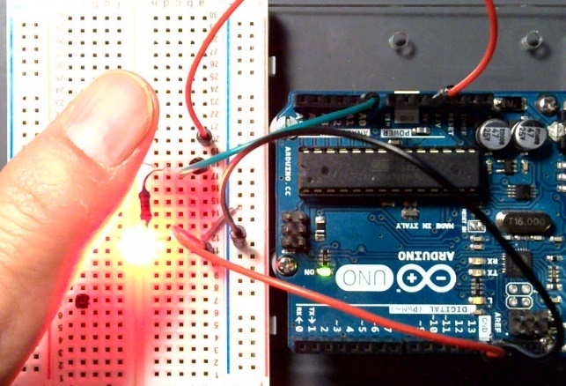
Covered Sensor – LED ON

The Night Light Challenge
This can be a multi-day project: See additional Warm-up & Exit questions in the Appendix.
Lesson Objective
Students will apply their knowledge to create an automated night-light.
Essential Question
What is an automatic night light and how does it work?
Warm-Up Question: Do you know how night lights work?
Exit Question: What is an automatic Night Light? And how do Automatic Night Lights work?
Cross-Cutting Concepts
Next Generation Standards Addressed
HS-ETS1-2 Engineering Design
HS-ETS1-3 Engineering Design
Assignments
Draw: a simple Technical Sketch on your graph paper to demonstrate your understanding of the Night Light. Specifically, how the LED, the 10 kOhm Resistor, and the Light Dependent Resistor connect from the Breadboard to the Arduino.
Create: an Arduino Sketch that uses a Light Dependent Resistor that, when covered, turns on an LED.
o Please take a video up to 20 seconds of the LED turning on while covering the Light Dependent Resistor.
o Although the Sketch/Code is provided, I encourage you to type the code for yourself.
- Please type the code out yourself.
- Please label each line of code in your own words.
Assignments
1. Draw the Technical Sketch using graph paper, pencil, colored pencils, and ruler and turn into class.
2. Create an Arduino Sketch/Code to operate your “Night Light”.
3. Construct your Microcontroller for a “Night Light”.
4. Take a video up to 20 seconds of your “Night Light” and turn in the video to your teacher.

UNIT 5
The Ultrasonic Sensor - Unit 5.1
Using the Ultrasonic Sensor to Light an LED
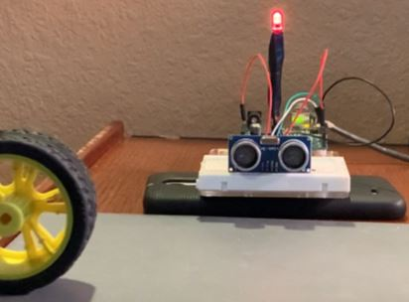
LED Lit with Obstruction
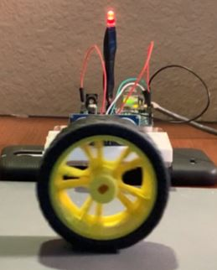
LED Dim WITH Obstruction

Using the Ultrasonic Sensor to Light an LED
This is a multi-day project: See additional Warm-up & Exit questions in the Appendix.
Lesson Objective
Students will learn about the Ultrasonic Sensor HCSR-04. Additionally, students will also learn how to program the Arduino to use an Ultrasonic Sensor to detect ranges and use LED’s, Buzzers, and Servo Motors as the output signals.
Essential Question
How does an Ultrasonic sensor work and what do they detect and measure?
Cross-Cutting Concepts
Next Generation Standards Addressed
HS-ETS1-2 Engineering Design
HS-ETS1-3 Engineering Design

Warm-Up Question: How do you think motion light sensors operate?
Exit Question: How can an Ultrasonic Sensor operate and how does the sensor collaborate with LED’s, servo motors and speaker outputs?

Assignments
Discussion: This lesson details the Ultrasonic Sensor (HC-SR04). The presentation will explain how the sensor sends and receives signals. The video will direct the teacher/student with an example of how the sensor operates with a real-world example.
Research: Research bat and submarine sonar to gain a deeper understanding of how sonar determines distance. In your research, what other information can sonar collect?
Video: Watch or Show the Video Ultrasonic Range Sensor & Application.
Draw: a Technical Sketch on your graph paper to demonstrate your understanding of how the LED, the 220 Ohm Resistor, and the Ultrasonic sensor connect from the Breadboard to the Arduino.
Create: an Arduino Sketch that uses an Ultrasonic sensor that, when covered, changes the light intensity of an LED.
- Although the Arduino Sketch/Code is provided, I encourage you to type the code for yourself.
- Please take a 10-15 second video of the LED dimming while moving your hand in front of the Ultrasonic sensor.
  - As you are recording your video, please verbalize (say) what is happening in your project.
  - Please put your hand in front of the sensor at 1 inch and describe what is happening and then move your hand further away from the sensor.
  - Next, put your hand in front of the sensor at 1 foot and then describe what is happening.
  - Please describe the difference in light intensities at 1 inch and 1 foot. Is one brighter than the other?
Setup your Breadboard and Microcontroller (Arduino/Elegoo) with an LED, Ultrasonic Sensor, and wiring to complete this project.

Unit 5.2
Using the Ultrasonic Sensor to Sound a Buzzer

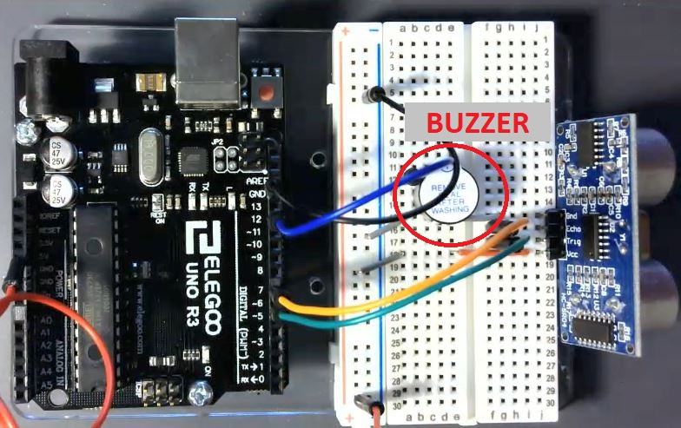
Sensor & Buzzer Setup
Using the Ultrasonic Sensor to Sound a Buzzer
This can be a multi-day project: See additional Warm-up & Exit questions in the Appendix.
Lesson Objective
In this lesson activity, students will code the Arduino to make a buzzer sound.
Essential Question
What is a buzzer? Why would it be important for a buzzer to sound and change pitches when detecting an object?
Warm-Up Question: How do you think an Ultrasonic Sensor can be used to sound a buzzer?
Exit Question: How can you use an Ultrasonic Sensor to make an alarm?
Cross-Cutting Concepts
Next Generation Standards Addressed
HS-ETS1-2 Engineering Design
HS-ETS1-3 Engineering Design
Assignments
Research: Research sensors that activate buzzers and the sensor’s purpose (reason) for activating (turning on) the buzzer.
Video: Watch the video titled “Ultrasonic Range Sensor & Buzzer”
Discussion: Students will program a buzzer to play a different tone based on the distance from the sensor. At greater distances, lower tones will be played. At closer distances, higher tones will be played. 6) Review code with students.
Draw: a Technical Sketch on your graph paper to demonstrate your understanding of how the Speaker, the Resistor, and the Ultrasonic sensor connect from the Breadboard to the Arduino.
Create: an Arduino Sketch that uses an Ultrasonic sensor that detects distance and changes the pitch in a buzzer when one moves his or her hand closer and further from the sensor.
- Although the Arduino Sketch/Code is provided, I encourage you to type the code for yourself.
- Please take a 10-15 second video of the Speaker sounding while moving your hand in front of the Ultrasonic sensor.
- Put your hand in front of the sensor at 1 inch and describe what is happening, and then move your hand away.
- Next, put your hand in front of the sensor at 1 foot and then describe what is happening.
- Describe the difference in pitches at 1 inch and 1 foot. Where does the pitch go higher? And lower?
  - In the video, please say what is happening in your project.
- The code for this project is pasted on the assignment sheet.
- Please type each line of code.
- Write a description of each line of code in your own words - what is happening in the code.
Unit 5.1
Using the Ultrasonic Sensor to Light an LED & Sound a Buzzer
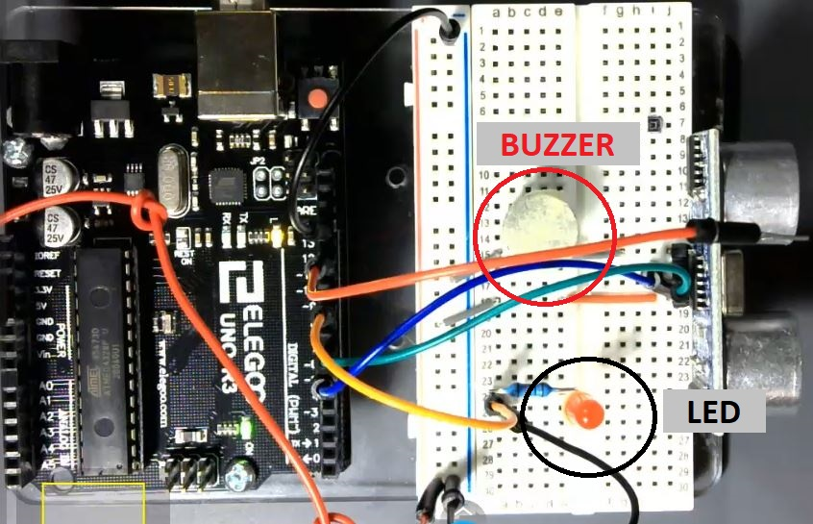
Sensor, LED & Buzzer Setup

Using the Ultrasonic Sensor
to Light an LED & Sound a Buzzer
This can be a multi-day project: See additional Warm-up & Exit questions in the Appendix.
Lesson Objective
In this lesson activity, students will code the Arduino to make a buzzer sound.
Essential Question/Warm Up Question
Why would it be important for an LED to light up while simultaneously sounding a buzzer to detect an object?
Warm-Up Question: How do you think a buzzer and an LED be integrated together to work inside of a system together?
Exit Question: How do you plan to integrate the buzzer and LED into your project?
Cross-Cutting Concepts
Next Generation Standards Addressed
HS-ETS1-2 Engineering Design
HS-ETS1-3 Engineering Design

Assignments
Video: Watch the video title “Ultrasonic Range Sensor, LED, & Buzzer”
Research: Next, have students research sensors that activate lights and buzzers simultaneously and the sensor’s purpose for activating them.
Discussion: Discuss with class various applications of how lights and sounds are integrated within an electronic system. Provide some of your own examples.
Draw: a Technical Sketch on your graph paper to demonstrate your understanding of how the Speaker, the LED, and the Ultrasonic sensor connect from the Breadboard to the Arduino.
Create: an Arduino Sketch that uses an Ultrasonic sensor that detects distance, sounds a buzzer, and lights an LED when an object is detected by the ultrasonic sensor.
- Although the Arduino Sketch/Code is provided, I encourage you to type the code for yourself.
- Please take a video up to 20 seconds of the buzzer sounding and LED lighting up while moving your hand in front of the Ultrasonic sensor.
- Please put your hand in front of the sensor at 1 inch and describe what is happening and then move your hand away.
- Next, put your hand in front of the sensor at 1 foot and then describe what is happening.
  - In the video, please verbalize (say) what is happening in your project.
  - The video should take no more than 15-20 seconds.
Unit 5.4
Using the Ultrasonic Sensor to Control a Continuous Servo
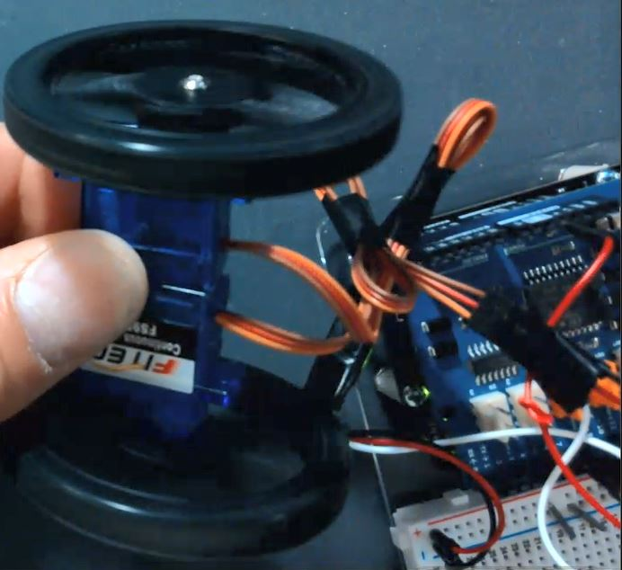
Servo Motors Running with Code

Using the Ultrasonic Sensor to Control a Continuous Servo
This can be a multi-day project: See additional Warm-up & Exit questions in the Appendix.
Lesson Objective
In this lesson, students will understand the differences between standard servos and continuous servos and learn how to control them using the Arduino.
Essential Question
Why would it be important for wheels to change directions to avoid an object?
Warm-Up Question: How would you define each of the servos so that the program does not “confuse” them?
Exit Question: How do you think you want to code your servos to work on your rover? How do you want them to maneuver your rover? Do you want them to stop, go back and then turn around? Do you want it to stop and turn right?
Cross-Cutting Concepts
Next Generation Standards Addressed
HS-ETS1-2 Engineering Design
HS-ETS1-3 Engineering Design
Assignments
Video: Watch the video titled “Ultrasonic Range Sensors and Continuous Servo Motors”
Research: Research self-driving cars.
Draw: a Technical Sketch on your graph paper to demonstrate your understanding of how the Servos and Ultrasonic Sensor attach to the Arduino.
Create: an Arduino Sketch that uses an Ultrasonic sensor that detects distance and changes the direction of a Servo Motor when an object is detected by the ultrasonic sensor.
- Please take a video up to 20 seconds of the Servo Motors moving while you place your hand in front of the Ultrasonic Sensor.
  - In the video, please say what is happening in your project.

Unit 6
Preparing Rover X

Unit 6.1
The Rover X Body Design
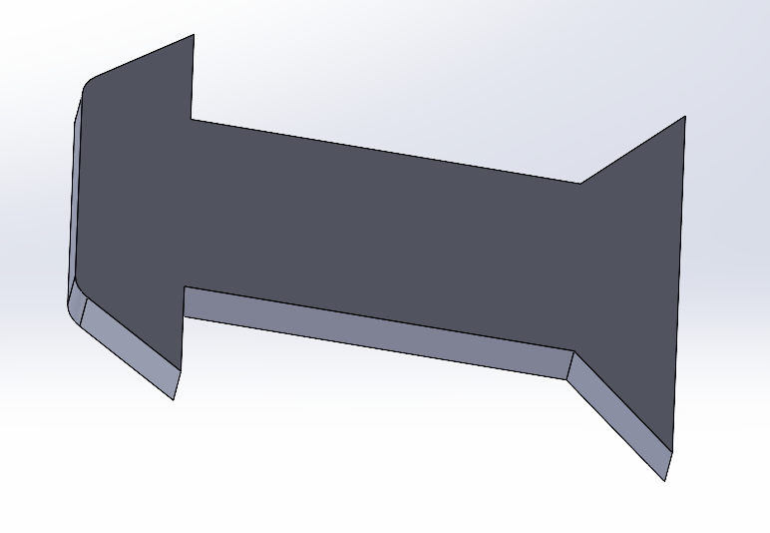
One Examples of a Simple Rover Design

Lesson Objective
In this lesson, students will build their Rover Body.
Essential Question
What is the best method for building a Rover body? How will you build your Rover body?
Warm Up Question: What are some design ideas that you have been considering for your rover body?
Exit Question: Given your research today, what was one thing that you did not initially consider making your rover body work better?
Cross-Cutting Concepts
Next Generation Standards Addressed
HS-ETS1-2 Engineering Design
HS-ETS1-3 Engineering Design
HS-ETS1-4 Engineering Design

Assignments
Video: Watch the video titled The Rover Body.
Research: Feel free to conduct research on your own Rover design for your project and produce your own design.
Discussion: Discuss with your team members what kind of design you will incorporate into your Rover design.
Draw: Students will either sketch on paper or Solidworks and turn in these drawings to the teacher. You may choose a design of your own!
Create: A Technical Sketch of your Rover body - this must be approved by your teacher.
- Once the design is approved, the student may build, or 3D print their design - depending on the capability of the Lab.
Here are a Few Rover Examples!

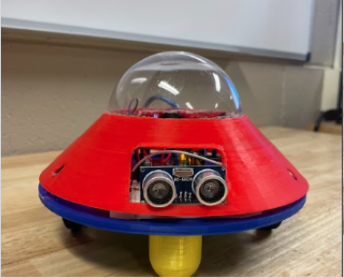 | 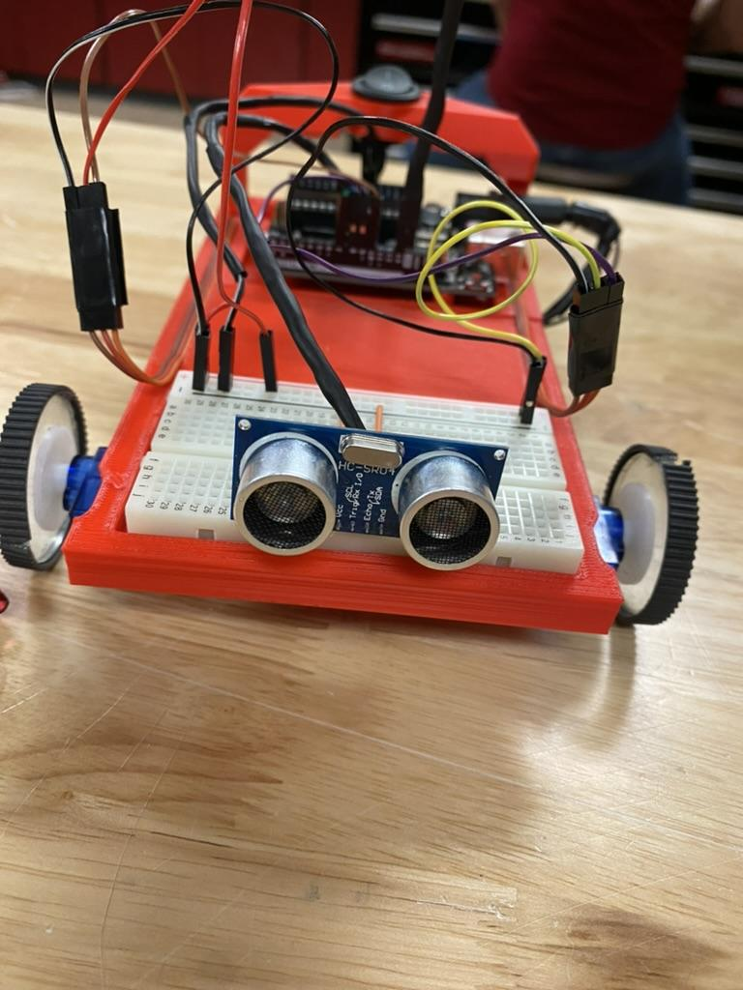
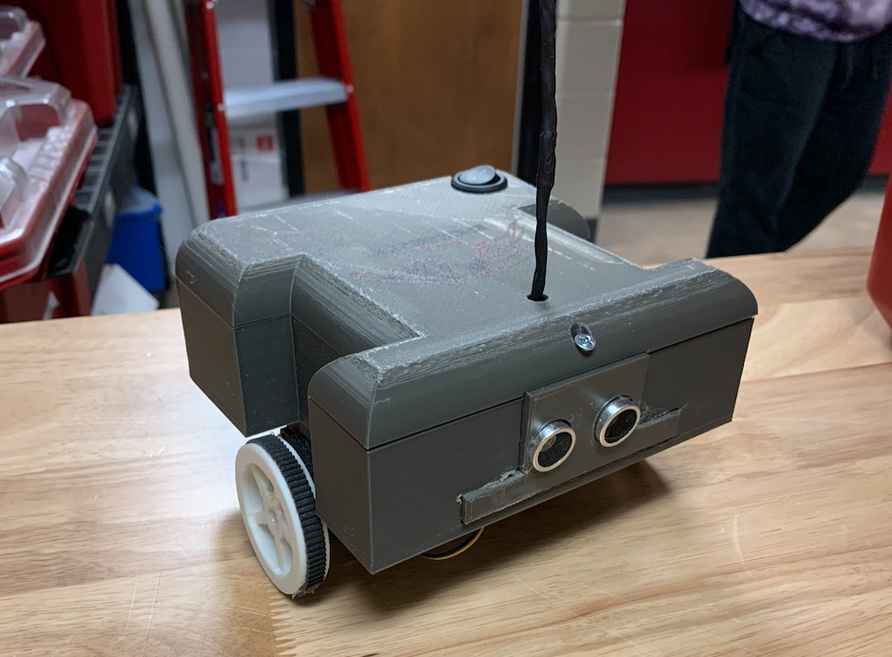 | 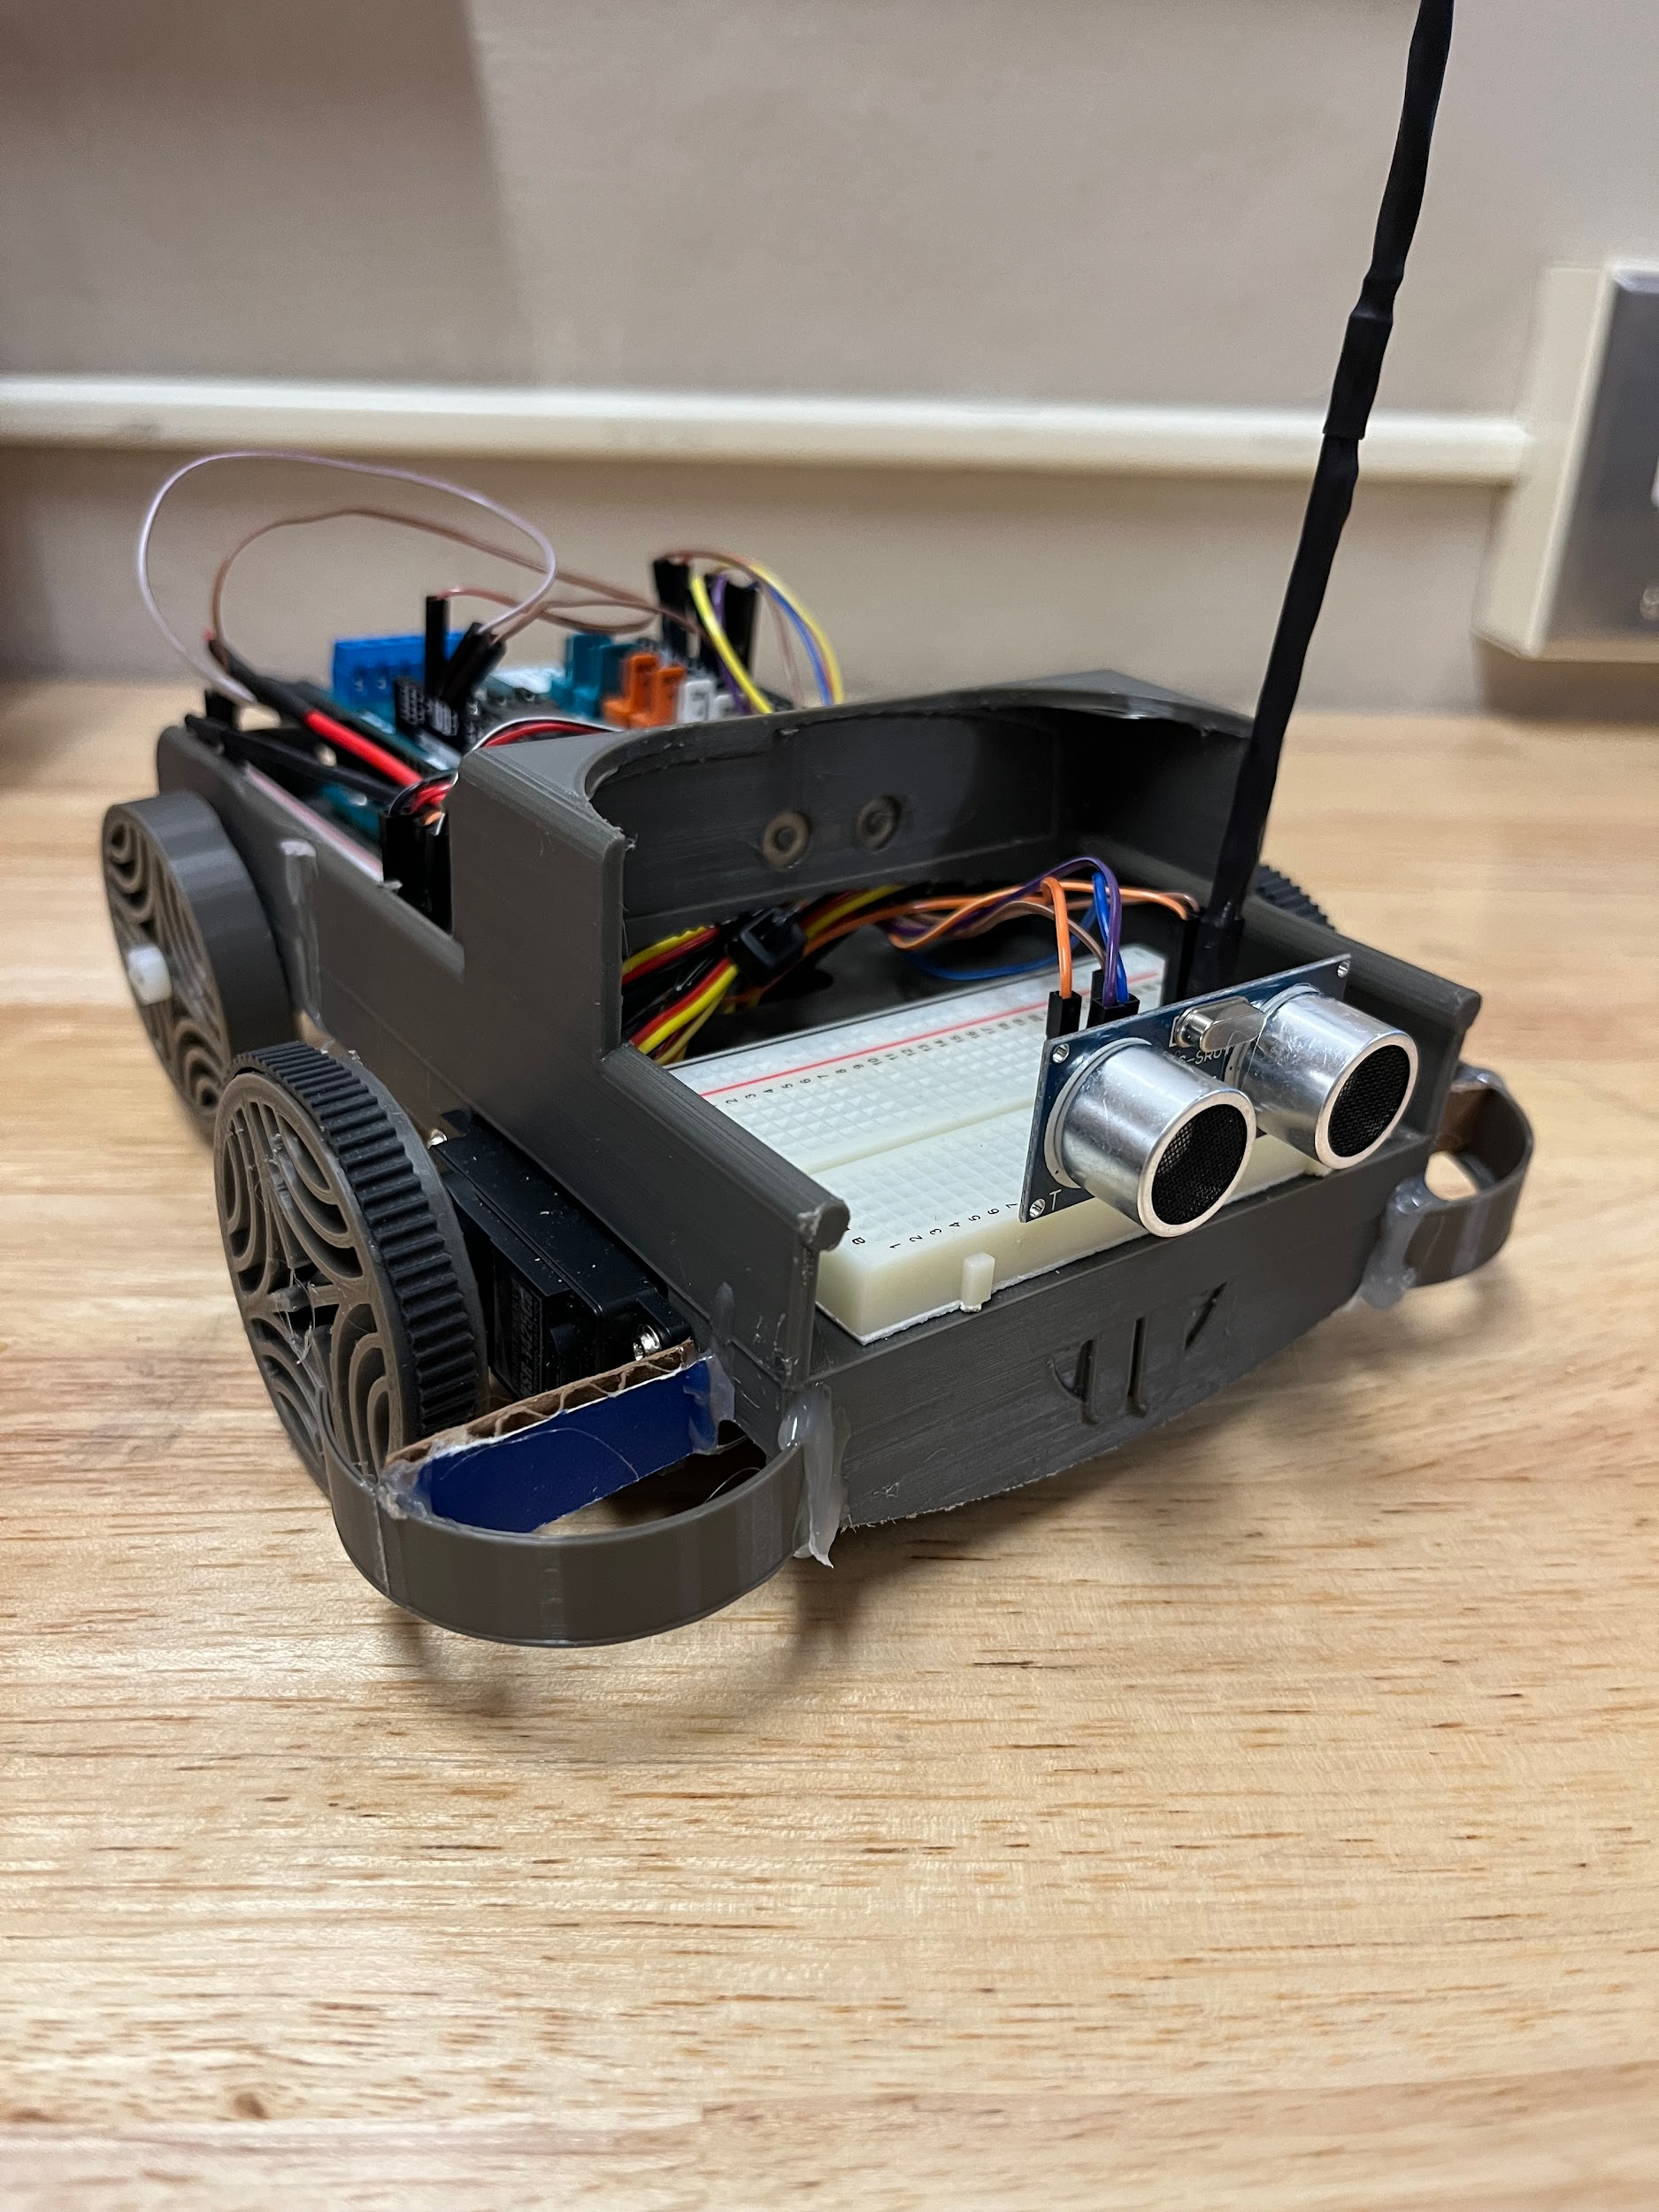

Unit 6.2
The LED
Lesson Objective
In this lesson, students will build their LED Rover Indicator.
Essential Question
What is the best method for building an LED Rover Indicator? How will you build your LED Rover Indicator?
Warm Up Question: How do you plan to use an LED in this project?
Exit Question: What are some design ideas that you have been considering for your LED Rover Indicator?
Cross-Cutting Concepts
Next Generation Standards Addressed
HS-ETS1-2 Engineering Design
HS-ETS1-3 Engineering Design
HS-ETS1-4 Engineering Design
Assignments
Video: Watch the video titled “The LED.”
Research: Feel free to conduct research on your own LED Rover Indicator design for your project.
Discussion: Discuss with your team members what kind of LED Rover Indicator you will incorporate into your Rover design.
Create: an LED Rover Indicator - must be approved by your teacher.
- Ensure that the LED fits into the design that the students have designed.
- You can either use tape or shrink wrap and a heat gun to make the LED indicator.

Unit 6.3
The Power Switch

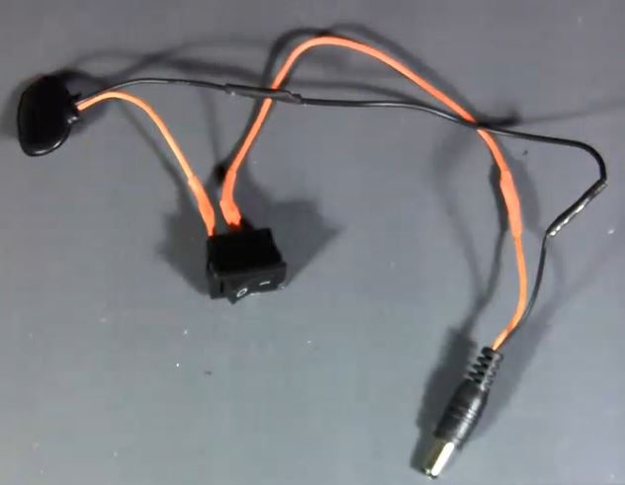
One Example of a Power Switch

Lesson Objective
In this lesson, students will build a Power Switch to turn their Rover “On” and “Off.”
Essential Question
What is the best method for building a Power Switch? How will you build your Switch?
–

Warm Up Question: What are some design ideas that you have been considering for your Power Switch?
Exit Question: If you use an external power source through the USB, where do you think you should place the switch to turn your rover on and off?
Cross-Cutting Concepts
Next Generation Standards Addressed
HS-ETS1-2 Engineering Design
HS-ETS1-3 Engineering Design
HS-ETS1-4 Engineering Design
Assignments
Video: Watch the video titled The Power Switch.
Research: Feel free to conduct research on your own Power Switch design for your project.
Discussion: Discuss with your team members what kind of Power Switch design you will incorporate into your Rover design.
Draw: An electrical schematic of how the Power Switch interfaces between the Rover Boy and the Power Supply.
Create: A sketch of your Power Switch - this must be approved by your teacher.
Unit 7
The Rover Build
Lesson Objective
In this lesson, students will build their Rover.
Essential Question
What are you planning to build for your final project? How will you do it? Why did you make the changes you made?
–
Warm Up Question: What are the final design ideas for your Rover?
Exit Question: What criteria and constraints are apparent for your final rover build?
Cross-Cutting Concepts
Next Generation Standards Addressed
HS-ETS1-1 Engineering Design
HS-ETS1-2 Engineering Design
HS-ETS1-3 Engineering Design
HS-ETS1-4 Engineering Design
Assignments
Video: Watch the video “Arduino Rover Example” to ensure that you understand how the Rover needs to operate.
Research: Feel free to conduct research on your own Arduino Autonomous Rover for your project.
Discussion: Discuss with your team members what kind of Arduino Autonomous Rover you will build.
Draw: 1) A Final Draft of the design of the Arduino Rover, 2) A Final Draft Technical Sketch of the electrical wiring for the Rover to include Power, All components, and Wiring.
Create: 1) An Arduino Sketch that utilizes an Ultrasonic sensor that detects distance and changes the direction of a Servo Motor when an object is detected. Also, an LED with illuminate and a buzzer will sound when the car stops and changes directions, 2) A PowerPoint of the Rover project to include all components of the build from start to prototype to final build - describing each step along the way, 3) An unedited video of no more than 30 seconds in length showing your Rover and describing how the code enables functionality of the Autonomous Rover.

FINAL Portfolio
PowerPoint Portfolio
Includes details from start to finish of Rover Build: initial design, prototype design, and final design.
Rationale for why each change was made.
Video embedded within the PowerPoint.
Reference slide
Example PowerPoint Portfolio following the Engineering Design Process

Printed Portfolio
Cover Page, Printed Rover Body Sketch, Printed Electrical Sketch, and Printed Arduino Sketch.
Technical Sketch(es) of the Rover to include dimensions.
Reference slide
Digital Example Coming Soon

Demonstration
Students will run a demonstration in which the Rover must avoid 7 obstacles within a course.
Example Video Demo
Glossary Terms
Arduino Sketch - The program that is written for microcontrollers.
Autonomous - The ability of a vehicle to travel by itself based on a computer program.
Breadboarding - A method for prototyping electronics that contains small pin holes for electronics to set.
Diode - A component that allows electrical current in only one direction.
Electrical Sketch - A detailed drawing on graph paper to show how the electrical components are connected. Color-coded, straight lines are required.
Light Dependent Resistor - A resistor that allows current to pass through based on light conditions. AKA - Photoresistor.
L.E.D. (Light Emitting Diode) - A single direction semiconducting component that when the current passes through, lights up.
Object Avoidance - The ability of a vehicle (rover) to either keep away or change directions when an object is present in its path.
Ohm - The unit of measurement for resistance.
Resistor - A component that limits the amount of current in a circuit.
Servo (Continuous) - A gear motor that requires electrical current to operate. Has a range of 360 degrees and can run “continuously” in the same direction.
Tactical Lines - Lines that are straight and travel along the grid lines on a sheet of graph paper.
Technical Sketch - A detailed drawing on graph paper to show how mechanical components are connected. Dimensions and annotations required.
Variables - The first location in an Arduino sketch. Used for name definitions of to-be-used items. (Example: You may want to place a name for your left servo motor, you would name it in this location, and you would denote it as: “Servo leftServo”)
Void Setup - The second location in an Arduino sketch. Used for defining the main function of your sketch and runs once.
Void Loop - The third location in an Arduino sketch. Used for defining the main function of your sketch and running over and over.
Warm-up/Exit Question Examples
Based on Glossary Terms
ARDUINO SKETCH
What is an Arduino sketch and how is it used in microcontroller programming?
- Answer: An Arduino sketch is a program written using the Arduino IDE that runs on Arduino boards. It is written in a language similar to C++ and includes two main functions: setup() and loop(). The sketch is used to control the behavior of the microcontroller, from reading inputs to controlling outputs like LEDs, motors, and other peripherals.
What defines an Arduino sketch?
- Answer: An Arduino sketch is a program written for Arduino hardware, composed in the Arduino IDE, using a C/C++ based syntax. It typically includes functions like setup() and loop() to control the board's operations.
How do you manage multiple tasks in an Arduino sketch?
- Answer: To manage multiple tasks in an Arduino sketch, you can use non-blocking code techniques such as millis() for timing, avoid using delay(), and sometimes employ state machines or libraries like Timer for more complex task management.
ELECTRICAL SKETCH
Can you describe the process of creating an electrical sketch for a simple circuit?
- Answer: An electrical sketch involves drawing the components of a circuit, such as batteries, resistors, and wires, and showing how they connect. It starts with a schematic drawing that represents the circuit components with symbols and lines that represent connections. This helps in planning and troubleshooting circuits before physically building them on a breadboard or a printed circuit board.
What are the key components of an electrical sketch for a home lighting circuit?
- Answer: An electrical sketch for a home lighting circuit typically includes the power source, switches, wiring, and light fixtures. It may also show grounding systems and circuit breakers.
How do you ensure safety when drafting an electrical sketch?
- Answer: Safety in an electrical sketch can be ensured by accurately representing all components according to electrical codes, including proper grounding and overload protection measures like fuses or circuit breakers.
AUTONOMOUS
What does it mean for a system to be autonomous, and can you give an example?
- Answer: A system is considered autonomous if it can operate on its own without human intervention. An example is an autonomous vehicle, which can drive itself to a destination using sensors and programming to navigate and avoid obstacles, all without a human driver.
What are some common applications of autonomous technology?
- Answer: Common applications include autonomous vehicles, drones, robotic vacuum cleaners, and automated industrial machinery, all designed to operate without human intervention.
How do autonomous systems make decisions?
- Answer: Autonomous systems use sensors and algorithms to collect and process data, make decisions based on machine learning models or pre-defined rules, and actuate controls accordingly.
BREADBOARDING
Explain the purpose of breadboarding in electronics.
- Answer: Breadboarding is used for prototyping electronic circuits. It allows developers to create and experiment with circuit designs without soldering. Components are inserted into the breadboard's sockets, and connections are made with jumper wires, making it easy to add, remove, or change parts of the circuit during testing and development.
Why is breadboarding a crucial step in circuit design?
- Answer: Breadboarding allows designers to experiment with circuit layouts, evaluate theories, and troubleshoot components without permanent soldering, facilitating easy modifications and optimizations.
What are some limitations of using a breadboard?
- Answer: Limitations include unreliable connections, a limited number of available connections, and unsuitability for high-frequency applications due to lack of shielding.
DIODE
What role does a diode play in an electrical circuit?
- Answer: A diode is a component that primarily allows current to flow in one direction (forward) and blocks it in the opposite direction (reverse). This property makes it useful for tasks like rectifying alternating currents to direct currents, protecting circuits by preventing reverse polarity, and regulating voltage.
What is the function of a diode in a solar panel system?
- Answer: In solar panels, diodes are used to prevent backflow of current which can protect the cells from damage and improve efficiency.
How does temperature affect the performance of a diode?
- Answer: Higher temperatures can increase the conductivity of a diode, potentially leading to higher leakage current and lower efficiency.
LIGHT DEPENDENT RESISTOR
How does a Light Dependent Resistor (LDR) work?
- Answer: An LDR is a component whose resistance decreases with increasing incident light intensity. It can be used to detect light levels; for instance, in street lighting systems, LDRs can turn on lights at dusk when the natural light decreases to a certain level.
What factors influence the resistance of an LDR?
- Answer: The primary factor is light intensity; resistance decreases as light intensity increases. Temperature can also affect sensitivity and resistance.
How would you use an LDR in a street lighting system?
- Answer: An LDR can be used to control when streetlights turn on or off by measuring the ambient light levels to activate the lights at dusk and turn them off at dawn automatically.
LED (LIGHT EMITTING DIODE)
Describe the function of an LED in an electronic circuit.
- Answer: A Light Emitting Diode (LED) is a semiconductor light source that emits light when current flows through it in the forward direction. LEDs are used in a variety of applications, from simple indicators to displays and lighting fixtures, due to their efficiency, longevity, and low energy consumption.
What are the advantages of LEDs over traditional incandescent bulbs?
- Answer: LEDs are more energy-efficient, have a longer lifespan, emit less heat, and are more environmentally friendly as they contain no toxic elements like mercury.
How do you choose a resistor for an LED circuit?
- Answer: The resistor value for an LED circuit is chosen based on the forward voltage of the LED and the desired current, using Ohm’s law to prevent excessive current that could damage the LED.
OBJECT AVOIDANCE
What is object avoidance in the context of robotics, and how is it implemented?
- Answer: Object avoidance is a critical functionality in robotics that prevents robots from colliding with obstacles. It is typically implemented using sensors like ultrasonic, infrared, or lidar that detect the presence of obstacles and help the robot to navigate around them by adjusting its path.
What sensors are commonly used in object avoidance systems in drones?
- Answer: Common sensors include ultrasonic, infrared, and LiDAR sensors, which help drones detect and navigate around obstacles.
How does object avoidance improve the functionality of autonomous vehicles?
- Answer: It enhances safety by preventing collisions, improves navigation capabilities, and increases the autonomy of vehicles by allowing them to make real-time path adjustments.
OHM’S LAW
Explain what Ohm’s Law is and give an example of its application.
- Answer: Ohm's Law states that the current through a conductor between two points is directly proportional to the voltage across the two points and inversely proportional to the resistance between them. For example, if you know the voltage across a resistor and its resistance, you can calculate the current flowing through it using the formula I = V/R.
What is Ohm's Law, and why is it important in circuit design?
- Answer: Ohm's Law states that the current through a conductor between two points is directly proportional to the voltage across the two points and inversely proportional to the resistance. It is crucial for designing circuits with the correct current and voltage levels.
How can Ohm's Law be used to calculate power dissipation in a resistor?
- Answer: Power dissipation can be calculated using the formula P = V² / R, where P is power, V is voltage, and R is resistance, derived from Ohm’s Law.
RESISTORS
What is the purpose of a resistor in an electronic circuit?
- Answer: A resistor's primary function is to limit the flow of electric current to certain parts of the circuit. This is crucial for protecting sensitive components from excessive current that could cause damage. Resistors are also used to control voltage levels, divide voltages, and handle power dissipation within circuits.
SERVO MOTOR
How does a servo motor work and what distinguishes a continuous servo from other types?
- Answer: A servo motor is a rotary actuator that allows for precise control of angular position, velocity, and acceleration. It consists of a suitable motor coupled to a sensor for position feedback. A continuous servo can rotate at varying speeds and directions indefinitely, unlike a standard servo, which is limited to movement between 0 and 180 degrees. Continuous servos are typically used for driving wheels or other components that need to make complete rotations.
What distinguishes a continuous servo from a standard servo motor?
- Answer: A continuous servo can rotate indefinitely in either direction at varying speeds, whereas a standard servo has a limited range of motion, typically 180 degrees.
How do you control the speed and direction of a continuous servo motor?
- Answer: Speed and direction are controlled by the width of the pulse sent to the servo via PWM (Pulse Width Modulation), with different pulse widths determining speed and pulse direction.
TACTICAL LINES
What role do tactical lines play in a technical sketch?
- Answer: Tactical lines help to guide the viewer’s attention to the most important parts of the sketch, enhancing readability and understanding.
How can tactical lines be used in a floor plan sketch?
- Answer: In floor plans, tactical lines can be used to denote boundaries, pathways, or areas of importance, ensuring that viewers focus on key elements.
TECHNICAL SKETCH
What is the difference between a technical sketch and an artistic sketch?
- Answer: A technical sketch is precise and used for engineering or architectural purposes, focusing on accurate dimensions and scales, whereas an artistic sketch is more expressive and subjective.
How do annotations enhance a technical sketch?
- Answer: Annotations provide necessary details such as dimensions, materials, and assembly notes that are crucial for understanding and constructing from the sketch.
VOID SETUP
What is the purpose of the void setup() function in an Arduino sketch?
- Answer: The void setup() function is called once when the program starts and is used to initialize settings, pin modes, start libraries, etc.
VOID LOOP
What does void loop() do in an Arduino program?
- Answer: void loop() contains code that the Arduino continuously cycles through, allowing it to respond to changes in inputs, control outputs, and perform tasks repeatedly.
How can you use void loop() to read a sensor value and control an LED?
- Answer: In void loop(), you could read a sensor value with analogRead(), and based on this value, use digitalWrite() to turn an LED on or off depending on certain conditions (like a temperature threshold).

Technical Sketch Example - The Night Light Challenge

Arduino Sketch Example - The Night Light Challenge
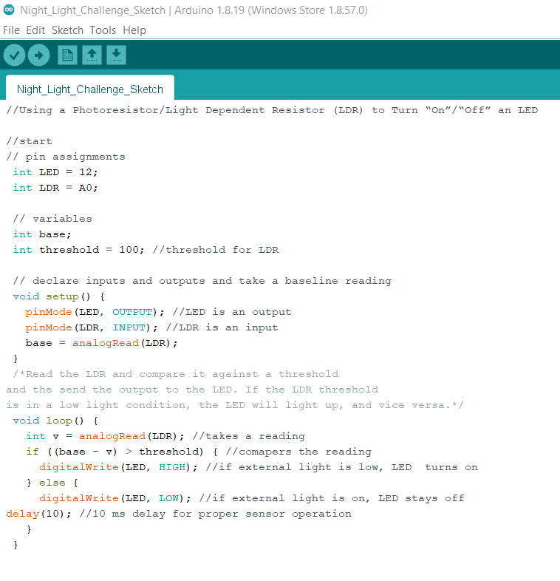
Next Gen Standards Addressed

Next Generation Science Standards (2024).
HS-ETS1-1 Engineering Design
Analyze a major global challenge to specify qualitative and quantitative criteria and constraints for solutions that account for societal needs and wants.
HS-ETS1-2 Engineering Design
Design a solution to a complex real-world problem by breaking it down into smaller, more manageable problems that can be solved through engineering.
HS-ETS1-3 Engineering Design
Evaluate a solution to a complex real-world problem based on prioritized criteria and trade-offs that account for a range of constraints, including cost, safety, reliability, and aesthetics as well as possible social, cultural, and environmental impacts.
HS-ETS1-4 Engineering Design
Use a computer simulation to model the impact of proposed solutions to a complex real-world problem with numerous criteria and constraints on interactions within and between systems relevant to the problem.
The Engineering Design Process – Focused Notes (Brown, Bronw, & Berkeihiser, 2023).
- Define the Problem: Outline the problem in clear terms.
  - Ensure that the problem statement does not limit creativity.
- Brainstorming: Identify several ways to solve the problem.
- Research & Generate Ideas: Based on research, begin to take the ideas from “brainstorming” and figure out the best approach.
- Identify Criteria & Constraints: How might the project design be limited?
  - Materials, cost, size, time, etc.
- Explore Possibilities:
  - Consider alternative solutions to the problem.
- Select an Approach: This is your approach to how you would like to solve the problem.
  - Ensure you can justify your answer.
- Develop a Design Proposal: Draw, sketch, jot your ideas down.
  - Paper or electronic
  - Show pictures in presentation.
- Model/Prototype: Create a model or prototype as a first attempt to solve your problem.
  - Show pictures in presentation
- Test & Evaluate: During and after the “model/prototype” is built. Test and evaluate parts, components, etc. – to figure out the best solution for a final product.
  - Use Pictures, videos.
  - Cyclical process with the “Refine” stage.
- Refine: Based on tests and evaluations, refine the idea to make the final (best) product.
  - Use Pictures, videos.
- Create or Make: Finalize the final product.
  - Use Pictures, videos.
- Communicate Results: Develop materials to communicate the project and process to others.
  - Each step must be documented.
  - Power Point, Poster, Portfolio, or the like.
  - Ensure you can answer the following questions.
    - What did you do?
    - How did you do it?
    - Why did you make those decisions?
Summary: The engineering design process is used to show a clear representation from idea generation to final product.

References
- Arduino.cc (2024). Arduino Website. Link: Arduino.cc.
- Brown, O., Brown, H., & Berkeihiser, G. (Year of Publication). Engineering fundamentals & design principles (3rd ed.). [Goodheart-Wilcox].
- Next Generation Science Standards. (2024). H.S. Engineering Design. Link: https://www.nextgenscience.org/topic-arrangement/hsengineering-design.
- Ted Talk. (June 27, 2012). How Arduino is open-sourcing imagination. Link: https://youtube.com/watch?v=UoBUXOOdLXY.

